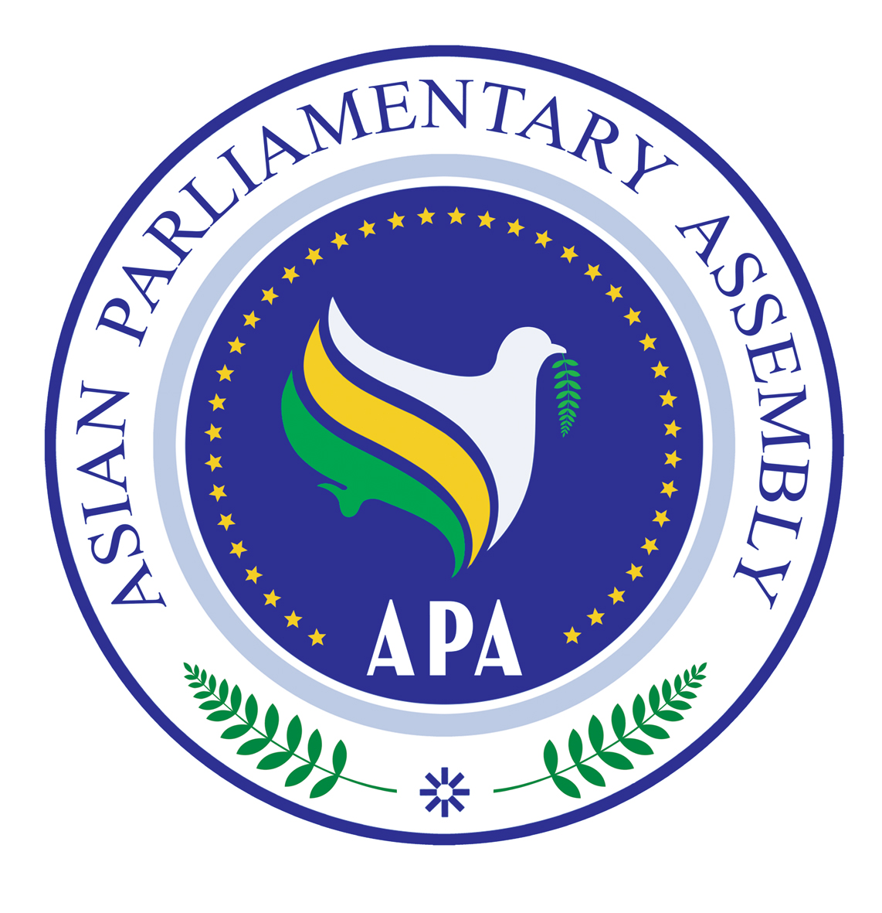

SC/Rep/2010/02
13 May 2010
Report of the Meeting
Standing Committee on Political Affairs
12-13 May 2010
Tehran
1. The Standing Committee on Political Affairs held its meeting on 12-13 May 2010 in Tehran, the Islamic Republic of Iran. APA Delegations from Afghanistan, Bahrain, Bangladesh, Cambodia, India, Indonesia, Iran, Iraq, Kuwait, Lebanon, Maldives, Pakistan, Palestine, Russia, Syria and Turkey participated in this meeting. The list of participants is attached as Annex I.

2. Honorable Hassan Aboutorabi Fard, the First Deputy Speaker of the Parliament of the Islamic Republic of Iran, delivered his opening statement at the beginning of the meeting. He underscored the significance of addressing the subjects under consideration of the meeting, particularly the issue of Palestine which is of paramount importance for APA Member Parliaments. H.E. Mr. M.H. Nejad Hosseinian, the APA Secretary-General, made his welcoming remarks in which he emphasized on cooperation and coordination amongst Member Parliaments in tackling problems in Asia, utilizing all potentials at the disposal of APA particularly the Troika plus mechanism.

3. Honorable Hassan Aboutorabi Fard was elected as the Chairperson; Honorable Moula Bakhsh Chandiso Khalil of Pakistan and Honorable Hassan Fadlallah of Lebanon were elected as Vice-Chairperson; and Honorable Try Chheang Huot of Cambodia was elected as the Rapporteur of the Committee.

4. The Sub-Committees on Major Issues of Peace and Security in Asia, Enhancing Cooperation between APA Member Parliaments and their Governments for Implementation of APA Decisions and the Declaration on Principles of Friendship and Cooperation in Asia met under the Standing Committee on Political Affairs.

5. The list of documents before the Meeting included:

a. The Sub-Committee on Major Issues of Peace and Security in Asia:
i) APA/Res/2009/02 of 10 December 2009, Fourth APA Plenary Session on Violations of International Humanitarian Law in Palestine and the War Crimes Committed By the Zionist Regime in Gaza,

ii) SG/Rep/2010/04/Rev.1 of 28 April 2010, the Report of the Secretary-General on Major Issues of Peace and Security in Asia,

iii) The honorable representative of Russia stated that his delegation's views on the three resolutions under this Sub-Committee will be conveyed to the Secretariat later.

iv) The honorable representatives of India and Turkey indicated that their positions on the third Operative Paragraph of the draft resolution on nuclear weapons will be conveyed to the Secretariat later.

b. The Sub-Committee on the Declaration on Principles of Friendship and Cooperation in Asia:

i) APA/Res/2008/09 and APA/Res/2008/09/Annex of 29 November 2008, Third APA Plenary Session on the Declaration on Principles of Friendship and Cooperation in Asia,

ii) SG/Rep/2010/05 of 21 April 2010, the Report of the Secretary-General on the Declaration on Principles of Friendship and Cooperation in Asia,

c. The Ad-hoc Committee on Enhancing Cooperation between APA Member Parliaments and their Governments for Implementation of APA Decisions:

i) APA/Res/2008/10 of 29 November 2008, Third APA Plenary Session on Enhancing Cooperation between APA Member Parliaments and their Governments for Implementation of APA Decisions,

ii) SG/ Rep/2010/06 of 27 April 2010, the Report of the Secretary-General Enhancing Cooperation between APA Member Parliaments and their Governments for Implementation of APA Decisions,

6. The Preliminary Reports of the Secretary-General to the three Sub-Committees had been forwarded to all Member Parliaments.

7. The Sub-Committees welcomed the Reports of the Secretary-General and expressed appreciation for the manner in which they were submitted to the Sub-Committees for their considerations.

8. The Secretary-General presented his oral reports on the three subjects of the Sub-Committees.

9. The Sub-Committees exchanged views on different elements and ideas in the Reports of the Secretary-General with a view to pursuing their objectives. The Sub-Committees took note of the suggestions for further steps to be taken as mentioned in the Reports of the Secretary-General.

10. Participating delegates further made some points in each Sub-Committee as follows:

a. The Sub-Committee on Major Issues of Peace and Security in Asia:
i) The APA should attach high importance to the issue of combating terrorism and foreign occupation and address this issue at different levels in Asia. APA Member Parliaments should share experiences in the fight against terrorism. An APA special committee may be established to discuss all issues related to terrorism.
ii) The Palestinian issue is a priority in all APA meetings. Palestine is not an Arab issue; rather it is an international humanitarian issue.
iii) The APA should stress the fact that it is against the threat or use of nuclear weapons. The peaceful use of nuclear energy should be available to all.

b. The Sub-committee on Reinforcing the Declaration on Principles of Friendship and Cooperation in Asia:
i) Asia has tremendous capacities and capabilities which should be explored in order to promote friendship and cooperation in Asia. Practical mechanism for further cooperation among Member Parliaments should be studied.
ii) Asian Parliaments should further activate the friendship groups existing in each Parliament.
iii) The Conference on Friendship and Cooperation in Asia to be held in 2011 in India may consider different aspects of the Declaration on Friendship and Cooperation in Asia including in the area of education, technology transfer, cultural exchanges and the establishment of a Friendship Committee in Asia.

c. The Sub-Committee on APA Measures for Enhancing Cooperation between APA Member Parliaments and their Governments for Implementation of APA Decisions:
i) It is necessary to establish contacts between parliamentarians and the representatives of governments.
ii) APA Parliamentarians are urged to talk to their Foreign Ministers to encourage them to participate in the 5th APA Plenary Session to be held in Damascus in 2010.
iii) A monitoring mechanism needs to be established for the implementation of APA decisions.
d. Ad-hoc Working Group on Information and Communication Technology “ICT”:

The Standing Committee on Social and Cultural Affairs which held its meeting on 14-16 March 2010 in Palau decided to establish an ICT (information and communication technology) Group to cover both ideas of Virtual Asian Parliament and Bridging the Digital Divide in Asia. The first meeting of ICT group was held at the side line of the Standing Committee on Political Affairs on 13 May 2010 in Tehran, the Islamic Republic of Iran. This meeting focused on the financial and technical requirements for establishing the “Asian Virtual Parliament”. It also welcomed the report of the Secretary General on “The Virtual Asian Parliament” and requests Member Parliaments to provide necessary arrangement for its implementation. The Ad-hoc Working Group decided to meet again in the side line of the Standing Committee on Economic and Sustainable Developments in Russian Federation on 17 June 2010, to expedite the establishment of the “AVP”. The text of the draft Resolution of this Ad hoc Working Group is also attached.

11. The Standing Committee expressed appreciation to the Parliament of the Islamic Republic of Iran for excellent organization of the meeting and the hospitality offered to all participants.

12. The Standing Committee recommended the following draft resolutions to the first APA Executive Council Meeting of 2010, to be forwarded to the APA plenary for its consideration:

SC/Res/2010/04
13 May 2010

Draft Resolution
On
The Role of Asian Parliaments
to Promote a Comprehensive Counter-Terrorism and Occupation Strategy

We, the Members of the Asian Parliamentary Assembly,

Inspired by the principles and objectives of the APA Charter;

Recognizing the fact that Asia has been the cradle of great religions, ancient civilizations and rich cultures;

Expressing determination to facilitate integration in Asia by promoting cooperation, enhancing respect for cultural and religious diversity, expanding interfaith and intercultural dialogue, and contributing to both regional and global efforts aimed at promoting a culture of peace and protecting human rights and the rule of law;

Considering foreign occupation as a violation of independence of the occupied countries that constitutes a real threat to peace and international security thus according the people under foreign occupation to resist occupation and exercise their right to self-determination in accordance with relevant UN resolutions;

Considering that acts of terrorism threaten the most fundamental human right, i.e., the right to life, and undermine social and economic development of states;

Reaffirming our commitment to oppose extremism, contribute to the peaceful settlement of disputes, and prevent and combat terrorism in all its forms and manifestations, including state terrorism;

Reaffirming also the need to develop a comprehensive counter-terrorism strategy, which includes a multi-disciplinary approach to this menace; addresses the root causes of terrorism, such as foreign occupation, state terrorism, political and economic injustices; avoids associating particular religious, national or ethnic groups with terrorism and demands compliance with a robust code of conduct in fighting terrorism;

Considering biased, domineering global political system, and non-compliance with and disrespect to international law by big powers to weakening and jeopardizing developing countries, provide ground for states terrorism and prolonging foreign occupation;

Expressing determination to promote parliamentary diplomacy with a view to contributing to the development of a comprehensive counter-terrorism strategy within an atmosphere of mutual confidence and solidarity in Asia and the world, particularly in the framework of international and regional cooperation through coordination and exchange of data and information between specialized institutions for the sake of combating international terrorism more effectively;

Recognizing that the struggle of peoples under foreign occupation or colonial domination to gain national freedom and exercise their right to self-determination is not, in any way, an act of terrorism;

- Condemn, in the strongest terms, acts of international and transnational terrorism in all its forms and manifestations, including state terrorism,
- Confirm that the struggle of peoples under foreign occupation or colonial domination to achieve freedom and exercise their right to self-determination does not, in any way, constitute acts of terrorism,
- Call upon member parliaments to adopt appropriate policies to promote comprehensive counter-terrorism strategy with a multi-disciplinary approach and to that end support the setting up of a Regional Task Force comprising Parliamentarians and civil society representatives mandated to monitor, evaluate and coordinate counter-terrorism practices of member countries;
- Call upon all Member Parliaments to help underscore, at national, regional and global levels, that an effective counter-terrorism strategy requires a genuine approach to address the root causes of terrorism, such as foreign occupation, state terrorism and international economic and political injustices, which tend to create an environment in which some people may fall victim to the rhetoric of terrorists and their organizations,
- Welcome the promotion of democratic system that constructively build our society's values through political opportunities that is adjusted to each countries needs as one of the methods in addressing the root causes of terrorism,
- Urge Member parliaments to develop campaigns to promote public debates about tolerance, respect for cultural and religious diversity, interfaith and intercultural dialogue and dialogue among civilizations, culture of peace, and rule of law as pillars of democracy and a means of preventing violence,
- Reject stereotyping of any religious, national or ethnic group and condemn any linkage between terrorism and any race, religion and culture,
- Confirm that the struggle of peoples under foreign occupation or colonial domination to achieve freedom and exercise their right to self-determination does not, in any way, constitute acts of terrorism,
- Confirm that a selective or exclusive approach to, application of double standard, and disregard for the rule of law in fighting corruption violate the principles and objectives of the United Nations Charter and seriously jeopardize the integrity of global effort to combat terrorism,
- Consider economic siege, use of force, the threat of use of nuclear weapons against other countries as an act of terrorism;
- Call for reform of global political system, specially the United Nations Security Council in order to promote respect for the principles and rules of international law with a view to achieving greater justice for all ,
- Invite Member Parliaments to exchange their best practices, particularly in the area of tolerance and interfaith and intercultural dialogue, in the fight against terrorism,
- Call upon all Member Parliaments to take steps, in coordination with their governments and in partnership with other inter-parliamentary organizations, to implement this resolution,
- Request the Secretary-General to establish a mechanism to exchange data and information between APA Member Parliaments on Comprehensive counter-terrorism strategy in order to maintain peace and stability in the region,
- Request also the Secretary-General to seek the views of Member Parliaments on measures taken to implement this resolution and to report thereon to the next meeting of the Sub-Committee on Major Issues of Peace and Security.

SC/Res/2010/05
13 May 2010

Draft Resolution on
Supporting the Rights of Palestinian People

Tehran, 12 May 2010

We, the Members of the Asian Parliamentary Assembly,

Recalling APA Resolutions on Violations of International Humanitarian Law in the Palestine and the War Crimes Committed By the Zionist Regime in Gaza (APA/Res/Political/2009/01, 8 December 2009); and Humanitarian Crisis in Palestine in Particular in the Gaza Strip (APA/Res/2008/08, 29 November 2008);

Inspired by the Principles and objectives enshrined in the APA Charter and the relevant APA resolutions;

Guided by the principles and objectives of the Charter of the APA;

Affirming the responsibility of the International community to promote human rights and ensure respect for International Law;

Reaffirming the applicability of the fourth Geneva Convention relative to the protection of Civilian Persons in Time of War, of 12 August 1949, to the Occupied Palestinian Territory, including Al-Guds Al-Sharif;

Expressing serious concern at the lack of implementation by the occupying power, Israel, of all resolutions and recommendations of the UN Security Council, the General Assembly, the Human Rights Council and the Inter-Parliamentary Union in relations to the human rights situation in the Occupied Palestinian Territory, including Al-Guds Al-Sharif;

Recognizing that the Israeli military attacks and operations in the occupied Palestinian territory, particularly the recent ones in the occupied Gaza strip, have caused severe violations of international humanitarian law and of the human rights of the Palestinian people therein and undermine international efforts towards achieving a just and lasting peace in the region;

Recognizing also that the Israeli siege imposed on the Occupied Gaza strip, including the closure of border crossing, constitute collective punishment and leads to disastrous humanitarian, economic, social and environmental consequences.

Committed to contribute to the promotion of peace and security at regional and global levels on the basis of justice and the rule of law;

Recalling Attention to the Report of the United Nations Fact Finding Mission on the Gaza Conflict (A/HRC/12/48, 15 September 2009) and the Resolution of the United Nations General Assembly on the Report of the Human Rights Council (A/64/53/add.1, 16 October 2009);

- Denounce all violations of international law which threaten international peace and security including all acts of terrorism and organized crimes; and violations of human rights committed by the Israeli occupying forces.
- Condemn deliberate violations of international humanitarian law by the Israeli occupying forces in Palestine, as partly reported in the Report of the United Nations Fact Finding Mission on the Gaza Conflict amounting to grave breaches of the Fourth Geneva Convention.
- Demand that the Zionist regime, the occupying power, stop targeting the Palestinian civilians and the systematic destruction of the cultural heritage of the Palestinian people, in addition to the destruction of public and private properties, as laid down in the Fourth Geneva Convention;
- Underscore the grave breaches of the Geneva Conventions and acts raising individual criminal responsibility under international criminal law and remind the duty imposed by the Geneva Conventions on all High Contracting Parties to search for and bring before their courts those responsible for these violations.
- Encourage all members of the international community to put pressure on the Zionist occupying regime to immediately release all the Palestinian prisoners including the Members of the Palestinian Parliament; dismantle all the settlements as well as the entire separating wall and put an end to its policies of assassinating Palestinian leaders, mass deportation of the Palestinian people and confiscating Palestinian lands.
- Call Upon all members of the APA and the United Nations as well as all regional and international organizations concerned, particularly the United Nations Security Council and the International Criminal Court to address, under the UN Charter and the Rome Statute, the crimes against humanity and the war crimes committed in Gaza Strip which threaten the international peace and security.
- Condemn the recent violations of human rights of occupying power in the occupied Palestinian territories, including their recent announcement to add Al-Haram Al-Ibrahimi in Al-Khalil and Bilal Mosque in Beit-Allahm in addition to the walls of the old city of Al-Quds Al-Sharif to their list of heritage sites,
- Demand the occupying power to respect the religious and cultural rights in the occupied Palestinian territories, particularly in Occupied Al-Quds Al-Sharif, as provided for in the Universal Declaration of Human Rights, the core international human rights instruments, the Hague Conventions, and the Geneva Conventions, and to allow Palestinian citizens and worshippers unhindered access to their properties and religious sites therein;
- Express its grave concern at the excavation of ancient tombs and removal of hundreds of human remains from part of the historic Ma’man Allah (Mamila) Cemetery in the Holy City of Al-Quds Al-Sharif in order to construct a “Museum of Tolerance” and call for discontinuation of such illegal activities therein;
- Urge the international community to put pressure on the occupying power for the immediate lifting of the siege imposed on the occupied Gaza Strip, and to open all borders and crossing points, and to allow the free access of fuel, humanitarian needs and medicine in addition to all necessary materials and equipments needed for the reconstruction and rehabilitation of Gaza.

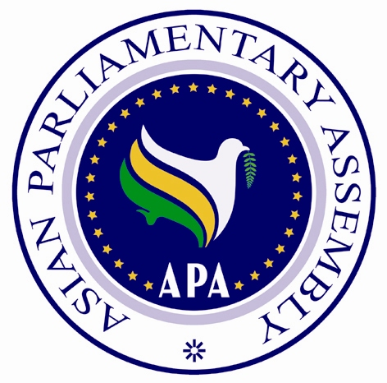

SC/Res/2010/06
13 May 2010

Draft Resolution on
Reinforcing the Declaration on Principles
of Friendship and Cooperation in Asia

We the Members of the Asian Parliamentary Assembly
RECALLING relevant APA Resolutions on the Friendship Pact in Asia; (APA/Res/2007/06, dated 19 November 2007); Text of the Friendship Pact in Asia (APA/Res/2007/06/Annex, 19 November 2007); and Resolution on Pursuing Implementation of the Declaration on the Principles of Friendship and Cooperation in Asia (APA/Res/2008/09, 29 November 2008);

WELCOMING the report of the Secretary General on Pursuing Implementation of the Declaration on the Principles of Friendship and Cooperation in Asia, contained in document SG/Rep/2010/05, 21 April 2010, to the Inter-Sessional Meeting under the APA Standing Committee on Political Affairs held on 12-14 May 2010,in Tehran, Islamic Republic of Iran;
COGNIZANT of the deep-rooted ties of history, geography, culture, and civilization which bind our peoples together;
CONSCIOUS of the common interests and shared objectives of the people of Asia pointing to the need for further cooperation;
COMMITTED to promote peace and security, at global as well as continental levels, on the basis of justice and the rule of law through expanding cooperation with all peace-loving nations within and outside Asia;
CONVINCED that the Declaration on the Principles of Friendly Relations in Asia provides a framework for convergence and a platform for active interaction at a macro level throughout the region;
RECOGNIZING the constructive role of the Asian Parliamentary Assembly in paving the way for strengthening amity and the friendly relations among the Asian Nations and States in all areas;
ENCOURAGING further expansion of friendly relations including cultural, diplomatic, scientific, and commercial relations among all Asian States and further communication and interaction among our Nations in pursuance of the purposes of the Declaration;

1. Call Upon all Member Parliaments to consider passing and endorsing the Declaration on the Principles of Friendship and Cooperation in Asia, as contained in APA/Res/2008/09, 29 November 2008, within their national parliaments in accordance with their own internal procedures and to report to the Secretary-General on the progress they have made in this respect;

2. Determine to utilize capacities and good offices available to the Member Parliaments, Asian Parliamentary Friendship Associations, and the APA Secretariat to promote, publicize, and disseminate information about the Declaration on the Principles of Friendship and Cooperation in Asia.

3. Decide to support and sponsor organizing a conference in 2011, in (an Asian city to be confirmed later) with the general theme of Friendship and Cooperation in Asia inviting high-level governmental officials, eminent figures and prominent scholars across Asia in order to promote the APA Declaration on the Principles of Friendship and Cooperation in Asia; address various aspects of Asian integration; and enhance cooperation between Asian Parliaments and Governments. The Conference shall comprise specialized committees to address specific issue areas including environmental, cultural, economic, and political issues.

4. Request the Secretary-General to make necessary consultations and coordination with the APA Member Parliaments as well as interested Asian organizations and academic institutions for appropriate preparation of the conference on Friendship and Cooperation in Asia.

6. Decide to continue deliberations in order to make recommendations on ways and means of acquiring the endorsement of the Declaration by Asian parliaments and Governments for its international recognition.

SC/Res/2010/07
13 May 2010

Draft Resolution
On
The Necessity of Effective Security Assurance and
Denouncing the Use or Threat of Use of Nuclear Weapons in International Relations

We, the Members of the Asian Parliamentary Assembly,
Bearing in mind the need to allay the legitimate concern of the States of the world with regard to ensuring lasting security for their peoples,
Reaffirming that nuclear weapons pose the greatest threat to mankind and to the survival of civilization,
Taking into account the overwhelming wish of people of Asia to see their continent as a nuclear weapon free zone,
Reiterating the need to promote a nuclear-weapon-free zone in the Middle East as called for by many United Nations General Assembly resolutions since 1971.
Considering the use or the threat of use of nuclear weapons against non-nuclear weapon states as an act of terrorism,
Reaffirming further that complete and general disarmament and complete elimination of nuclear weapons is essential to removing the danger of nuclear weapons,
Determined to abide strictly by the relevant provisions of the Charter of the United Nations on the non-use of force or threat of use of force,
Recognizing that the security and territorial integrity of non-nuclear-weapon states need to be safeguarded against the use or threat of use of nuclear weapons,
Gravely concerned by any threat made by any nuclear weapon state to use nuclear weapons against non-nuclear weapon states,
- Emphasize the basic and inalienable right of all states to develop research, production and use of atomic energy for peaceful purposes including the development of fuel cycle, without any discrimination and in conformity with their respective legal obligations,
- Reaffirm that the use or threat of use of nuclear weapons is contrary to the charter of the United Nations and general international law, and emphasize the total elimination of nuclear weapons is the only absolute guarantee that there will be no use or threat of use of nuclear weapons,
- Condemn the recent threat of use of nuclear weapon by the United States or any other nuclear-weapon state against any APA member and other non-nuclear weapon states,
- Stress that non-Nuclear-Weapon States parties to the NPT should be effectively assured by Nuclear-Weapon States that there will be no use or threat of use of such weapons,
- Urge all nuclear-weapon states, to immediately denounce the option to use or threat of use of nuclear weapons against non-nuclear weapon states, and to engage with the international community to develop, as early as possible, an international agreement thereon with a view to total elimination of nuclear weapons and establishing a world free from nuclear weapons within a specified time table.

SC/Res/2010/08
13 May 2010

Draft Resolution on

Measures for Enhancing Cooperation
Between APA and Asian Governments

We, the Members of the Asian Parliamentary Assembly (APA),

RECALLING APA Resolution on Enhancing Cooperation between Asian Parliamentary Assembly Member Parliaments and Their Governments for Implementation of APA Decisions (APA/Res/2008/10, 29 November 2008)

WELCOMING the report of the Secretary General on Enhancing Cooperation between Asian Parliamentary Assembly Member Parliaments and their Governments for Implementation of APA Decisions, contained in document SG/Rep/2010/06, 21 April 2010, to the Inter-Sessional Meeting under the APA Standing Committee on Political Affairs held on 12-14 May 2010,in Tehran, Islamic Republic of Iran;

TAKING NOTE of the deliberations of the Inter-Sessional Meeting under the APA Standing Committee on Political Affairs on Enhancing Cooperation between Asian Parliamentary Assembly Member Parliaments and their Governments for Implementation of APA Decisions;

STRESSING the importance of adoption by APA Member Parliaments of common legislations on issues of particular interest to both APA Parliaments and Asian Governments with viable monitoring methods;

EMPHASIZING the need to foster closer coordination and cooperation between APA and governments of APA Member Parliaments;

1. Decide to invite Ministers of Foreign Affairs, or their representatives, of APA Member and Observer Parliaments to participate in the Executive Council and Plenary Sessions of the APA and to exchange views on the most significant and urgent issues in Asia and on the APA agenda;

2. Decide to appoint an APA delegate as a Focal Point within our Parliaments to be in charge of making regular coordination between our parliaments and governments on the one hand, and between our parliaments and APA Secretariat for the implementation of APA decisions and programs on the other;

3. Request the Secretary-General to expand the scope of its contacts and communications with inter-governmental organizations who work on issues relevant to the items on the APA agenda in order to facilitate further interaction and joint efforts on common grounds with a view to enhancing cooperation between Asian Parliaments and Governments and report thereon to the next session of the APA Executive Council.

SC/Res/2010/09
13 May 2010
Draft Resolution

Proposed by the Ad-hoc Working Group on
Information and Communication Technology “ICT”

We, the Members of the Asian Parliamentary Assembly,
Recalling APA Resolution, APA/Res/2009/04,
Welcoming the report of the Secretary-General to the open-ended Ad-hoc Working Group on ICT (SG/Rep/2010/07) dated 3 May 2010 submitted to the meeting of the ICT Group held in the Islamic Republic of Iran, 13, May 2010;
Stressing the view that global networking provides opportunities for APA Member Parliaments to share experiences and engage in fruitful dialogue on significant issues in Asia;
Emphasizing that the Establishment of the Virtual Asian Parliament constitutes an effective step to enhance dialogue and exchange of views among Asian Parliaments for further cooperation and coordination
Supporting the proposal for establishing the “Virtual Asian Parliament” to enhance deliberation and strengthen cooperation among Member Parliaments in more effective way;
- Welcome the Report of the Secretary-General on technical requirements of “Asian Virtual Parliament” that aims at enhancing deliberations among APA member parliaments.
- Request APA Member Parliaments to arrange in their own parliament the technical facilities for the establishment of the Virtual Asian Parliament.

- Request the Secretary-General to seek possible technical and financial assistance from Member Parliaments and other institutions to facilitate the establishment of VAP.
- Underline the necessity to work out the legal status of the materials and documents which will be circulated in Virtual Parliaments.
- Emphasize the need to resolve the challenges of communication channels for organizing video conferences which can be used for holding meetings of Virtual Asian Parliament.
- Request the secretariat to conduct a pilot project of VAP and share the result with the APA member parliaments.
- Decide to hold the next meeting of the ICT Working Group at the sideline of the meeting of the Standing Committee on Economic and Sustainable Developments to be held in Russian Federation on 17 June 2010, to expedite the establishment of the Virtual Asian Parliament.
- Request the Secretary-General to seek the views of the Member Parliaments on the progress made to implement this resolution and submit a report thereon to the next meeting.

ANNEX - I
List of Participants in the meeting of Standing Committee on Political Affairs
12 -13 May, 2010
No. | Name of Parliament | Delegate
1 | Afghanistan | Honorable Mr. Abdul Qaium Sajjadi, MP
2 | Bahrain | 1. Honorable Dr. Salah Ali Abdulrahman, Deputy Speaker  2. Honorable Mr. Khalil Ebrahim Al-Marzooq, MP  3. Honorable Mr. Fuad Ahmed Al-Hajee, MP  4. Honorable Mr. Sami Mohsen Al-Bahairi , MP  5. Mr. Ali Al-Aradi , Media Specilaist ( Secretary )  6. Mr. Basem Al-Malki, Admin Assistant (Secretary)
3 | Bangladesh | Honorable Mr. Mohammad Mostafa Fareq, MP
4 | Cambodia | 1 - Honorable Mr. Try Chheang HUOT, M.P  2-Honorable Senator Mr. Chhit Kim YEAT  3-Mr. Nguon Raksmey - Assistant  4-Mr Hok Bunly -Assistant
5 | India | 1 - Honorable Mr. Jai Prakash Agrawal, MP  2 - Honorable Mr. Tariq Anwar, MP  3 - Mr. Cyril John, Secretary to the Delegation
6 | Indonesia | 1. Honorable Mr. Abdurrahman Abdullah , MP  2. Honorable Mr. Prof. Cecep Syarifuddin MP  3. Mr. Indra Alverdian (Expert Staff/Secretary of Delegation)  4. Mrs. Rima Diah Pramudyawati (Ministry of Foreign Affairs)  5. Mr. Bayu Rahmat (Ministry of Foreign Affairs)
7 | Iran | 1 - Honorable Mr. M.H. Abutrabi Fard, First Deputy Speaker  2 - Honorable Mr. Hossien Amiri, MP  3 - Honorable Mr.Mohsen Nariman, MP  4 - Honorable Mr. Amir Taherkhani, MP  5 - Honorable Mr. Seyed Javad Zamani, MP  6 - Honorable Mr. Ghafori Fard, MP
8 | Iraq | Honorable Mr. Homam Al Hamodi, MP
9 | Kuwait | 1 - Honorable Mr. Askar Oweed Al Anzani, MP  2 - Honorable Mr. Saleh Ahmad Ashour, MP  3 – Mr. Jamal Abdullah Al Khamees, Director of Foreign Relations
10 | Lebanon | 1 - Honorable Mr. Hassan Fadlallah, M P  2 - Honorable Mr. Wahid Khoury, MP  3 – Mr. Hassan Yassine, Adviser
11 | Maldives | 1 - Honorable Mr. Ahamd Nazim, Deputy Speaker  2 - Honorable Mr. Ahmad Rashid Ibrahim
12 | Pakistan | 1 - Honorable Senator Mr. Moula Bakhsh Chandio  2 - Honorable Senator Mr.Moulana Mohammad Khan Sherani  3 - Honorable Senator Mr. Abdulrahimkhan Mandokhel  4 - Honorable Senator Mr. Seyed Zafar Alishah  5 - Honorable Senator Dr. Khalid Mahmood Soomro  6 - Honorable Senator Mr. Gul Naseeb Khan  7 – Mr. Mohammad Anwar, Deputy Secretary
13 | Palestine | 1 - Honorable Mr. Tayseer Qubaa, Deputy Speaker  2 - Honorable Mr. Zuhair Sanduka,MP  3 - Honorable Mr. Salah Zawawi,MP & Ambassador in Tehran
14 | Russian Federation | 1 – Honorable Mr. Rudik Iskuzhin, MP  2 – Mr. Vladimir Dashko, Assistant
15 | Syria | 1 - Honorable Mr. Ali Al Amoury, MP  2 - Honorable Mr. Mohammad Moteih Moaied, MP
16 | Turkey | 1 - Honorable Mr. A. Emin Onen, MP  2 - Honorable Mr. Tacidar seyhan, MP  3 – Mr. Murat Hasturk, Assistant

